COMP S313F Mobile Application Programming

Group Project Project Document

Project title: Hong Kong Walking Track (HKWT)

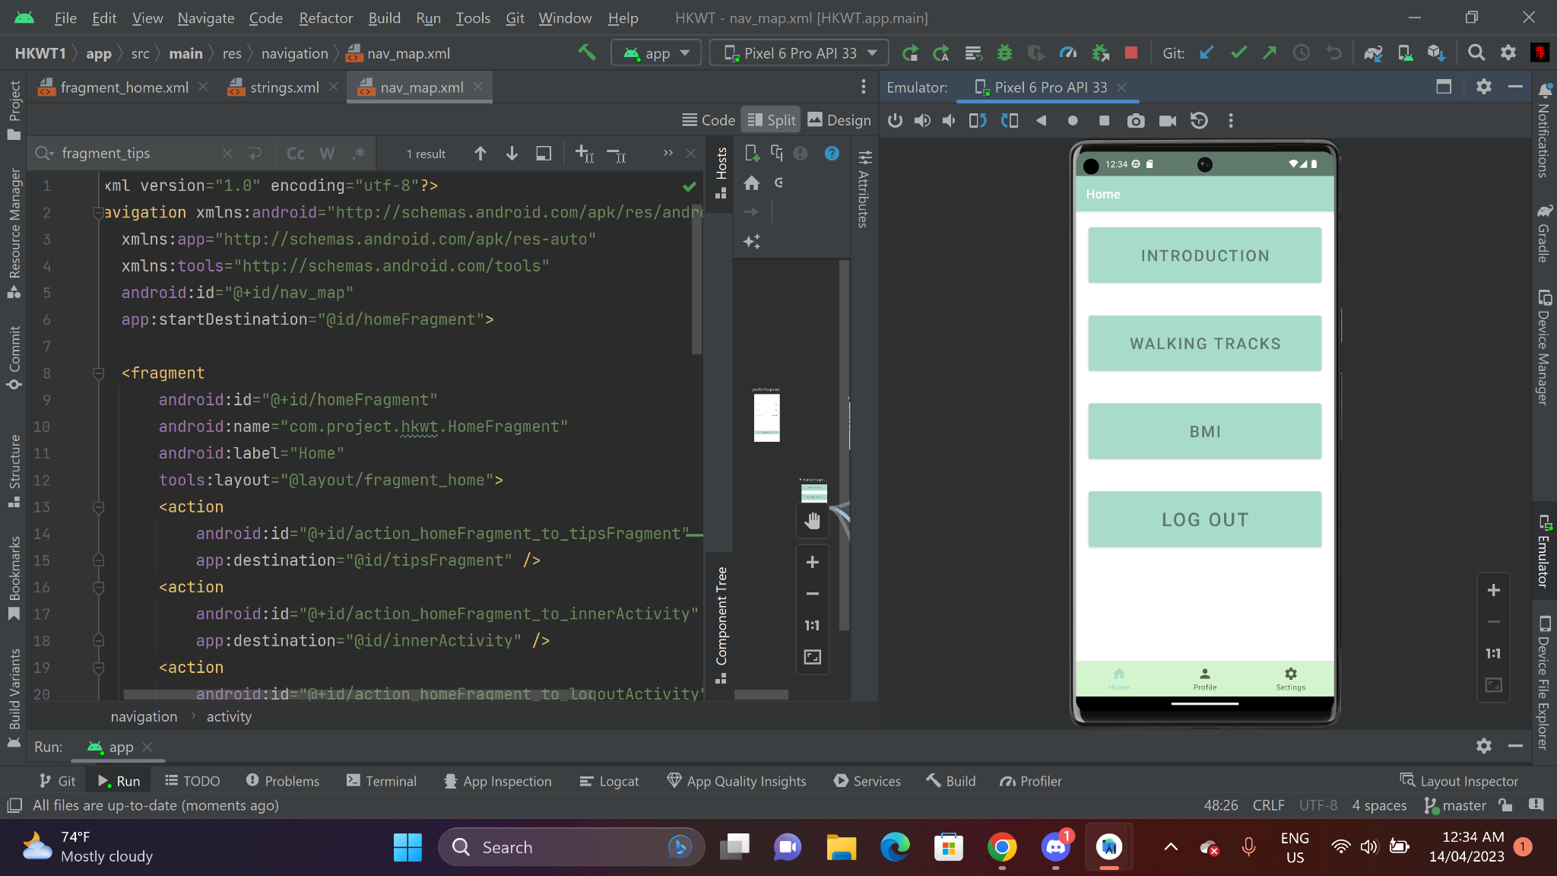

(Figure 0)

Student Name and Student ID of team members:

Yii Sze Ying 12666490

Hu Xinrong 12666998

Lo Wing Lun 13103419

Wong Pak Cheong 13079556

Chan Wai Chun 12990307

Tushar Bhavnani 13060949

Features in the application:

1. Register Function

The registration function (Figure 1) will gather user data such as Name, Email, Username, and Password then store them in a firebase, a cloud-based database that offers secure user data storage and retrieval. This function is programmed with validation checks to make sure users enter all relevant data, preventing partial submissions. After the registration procedure,a confirmation message will be received.

For the code study, please refer to “SignUpActivity.java”.

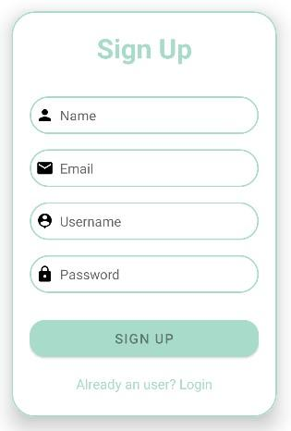

(Figure 1)

1. Login and Logout Function

Users can Log In to access customized services by entering the Username and Password. (Figure 2.1) An error and request message will be displayed if an erroneous Username or Password is entered. Firebase will check and confirm if the Username and Password are authenticated.

For the code study, please refer to “LoginActivity.java”

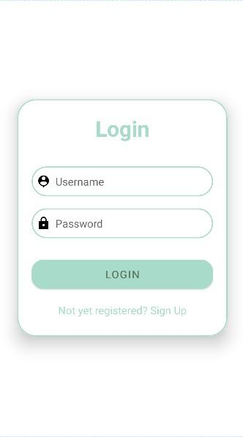

(Figure 2.1)

By clicking the Logout button (Figure 2.2), the user will be sent right back to the Login page. To prevent unintentional logouts, the interface will ask if the user really wants to log out. The application will delete the user's session and reroute them to the login page once they have confirmed their logout. The Logout procedure ensures that user data is kept secure and that after logging out, no unauthorized access is accepted.

For the code study, please refer to “LogoutActivity.java”

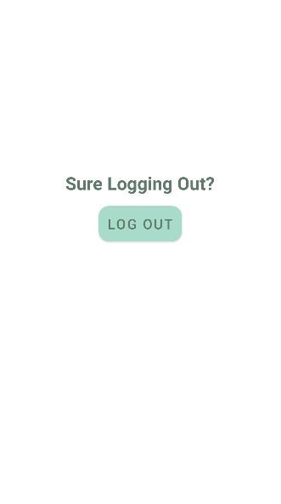

(Figure 2.2)

1. Tips

In the introduction part (first button in the home page) , tips are provided to the users for walking on the Fitness Tracks. (Figure 3)



(Figure 3)

1. Load Data and Image From Json File

Users can access all Hong Kong Fitness trails by clicking the "WALKING TRACK" button (Figure 0, second button in the home page). An informational JSON file about the fitness trails will be loaded by the program. (Figure 4.1)

For the code study, please refer to “InnerActivity.java”

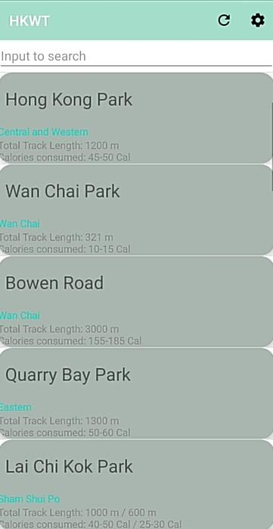

(Figure 4.1)

By clicking the walking track you would like to choose, the details of the walking will be shown in another page. (Figure 4.2) Users can click the “MAP” button in the bottom to view the actual location of the track in Google Map(Figure 4.3).

For the code study, please refer to “MapActivity.java”

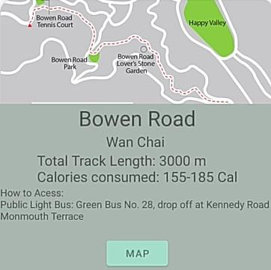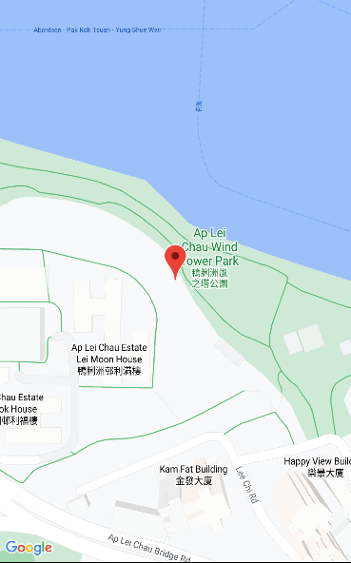

(Figure 4.2),(Figure 4.3)

4.1 Error response

Users can use the refresh button(Figure 4.1a) to reload the JSON file if no respond. This function makes sure that users can still obtain the fitness trails information they require even if there is a loading error.

For the code study, please refer to “MainActivity.java”



(Figure 4.1a)

4.2 Language

Users can use the settings button(Figure 4.2a), which direst users to the language function page, to change their language. Further information will be mentioned in “*8.2* *Switch Language*”

For the code study, please refer to “SettingsActivity.java”.



(Figure 4.2a)

4.3 Searching Function

Users can utilize the searching function(Figure 4.3a) to look up a specific walking track in Hong Kong. The GET and POST methods are used to access a JSON file and get pertinent information. Users can access the information they require effectively.

For the code study, please refer to “InnerActivity.java”.

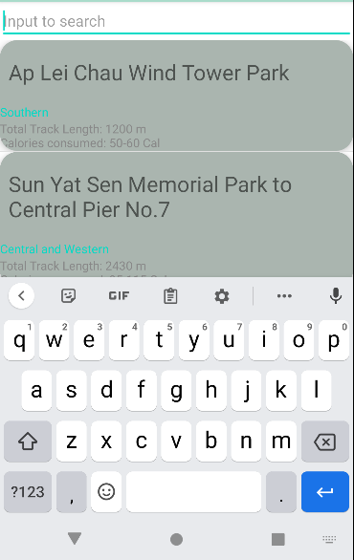

(Figure 4.3a)

1. BMI Calculator

By clicking the BMI button (Figure 0, the third button), BMI (Body Mass Index) of the user can be calculated by entering their height and weight. (Figure 5) By offering useful health data and encouraging healthy living choices, the BMI calculation feature improves the user experience. This feature allows users to set and monitor fitness goals, making it a crucial tool for people trying to lead healthy lives.

For the code study, please refer to “BMIActivity.java”.

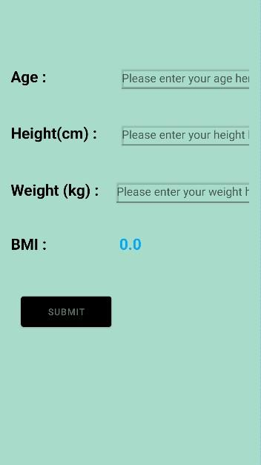

(Figure 5)

1. Profile

The personal information entered during registration (username, email, full name, and password) will be saved in the profile and firebase. (Figure 6.1) Users can use the profile editing function to update their personal information. (Figure 6.2) They may keep their profiles current and correct in the application with this feature, which improves the user experience.

For the code study, please refer to “ProfileFragment.java”.

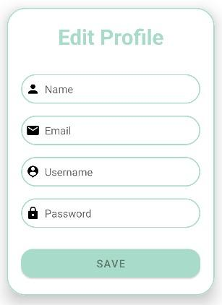 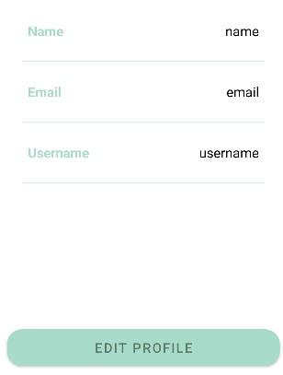

(Figure 6.1) (Figure 6.2)

1. Settings

A Setting page (Figure 7.1a & 7.1b) is also provided to the user for the personalized settings. Users can change the Visibility of the application, switch the Language of the application and log out the application.

For the code study, please refer to “SettingsFragment.java”

*7.1 Visibility*

As the color of the scene, text, and button in the “themes.xml” and “themes(night).xml” are set, users may manually switch between the dark mode and light mode in the settings page for their preference.

By clicking the checkbox of “Dark Mode” (Figure 7.1a), the background will be changed from light to dark, reducing blue light output and eye strain on the OLED panel.

By unclicking the checkbox of “Dark Mode” (Figure 7.1b), the background will be changed back to light mode.The conventional light backdrop display known as "Bright Mode" makes text easier to view in bright situations.

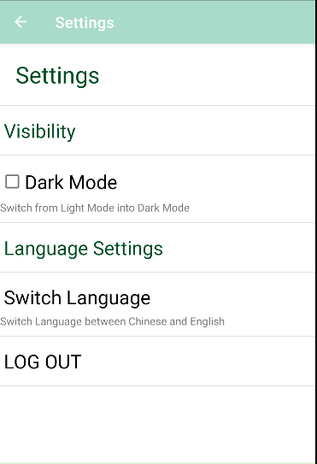 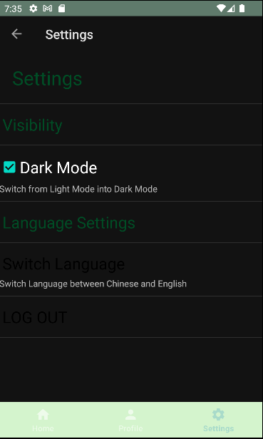

(Figure 7.1a) (Figure 7.1b)

*7.2 Switch Language*

By selecting the "Switch Language'' button in the settings page, users can change the language of the application. The interface translate works with string and translate functions provided in “string.xml”.

There are three language options provided: English(Figure 7.2a), Simplified Chinese(Figure 7.2b) and Traditional Chinese(Figure 7.2c). By accommodating different language preferences, the language option function makes finding tracks more accessible.

For the code study, please refer to “SettingsActivity.java”.

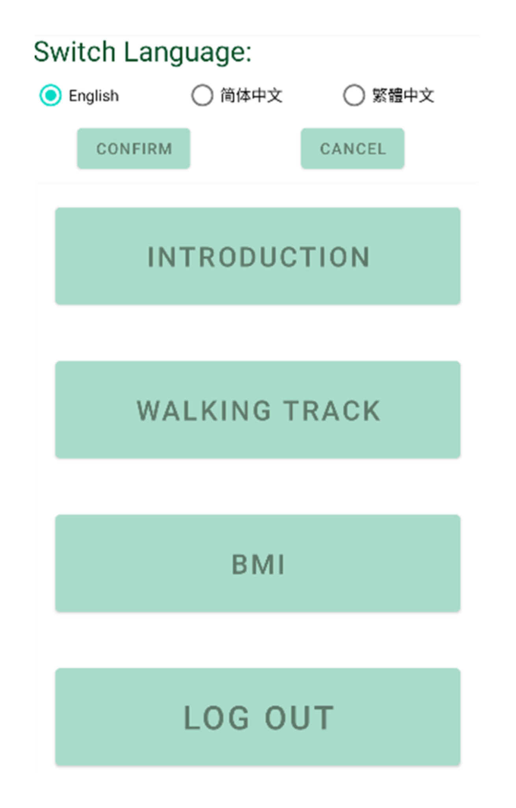 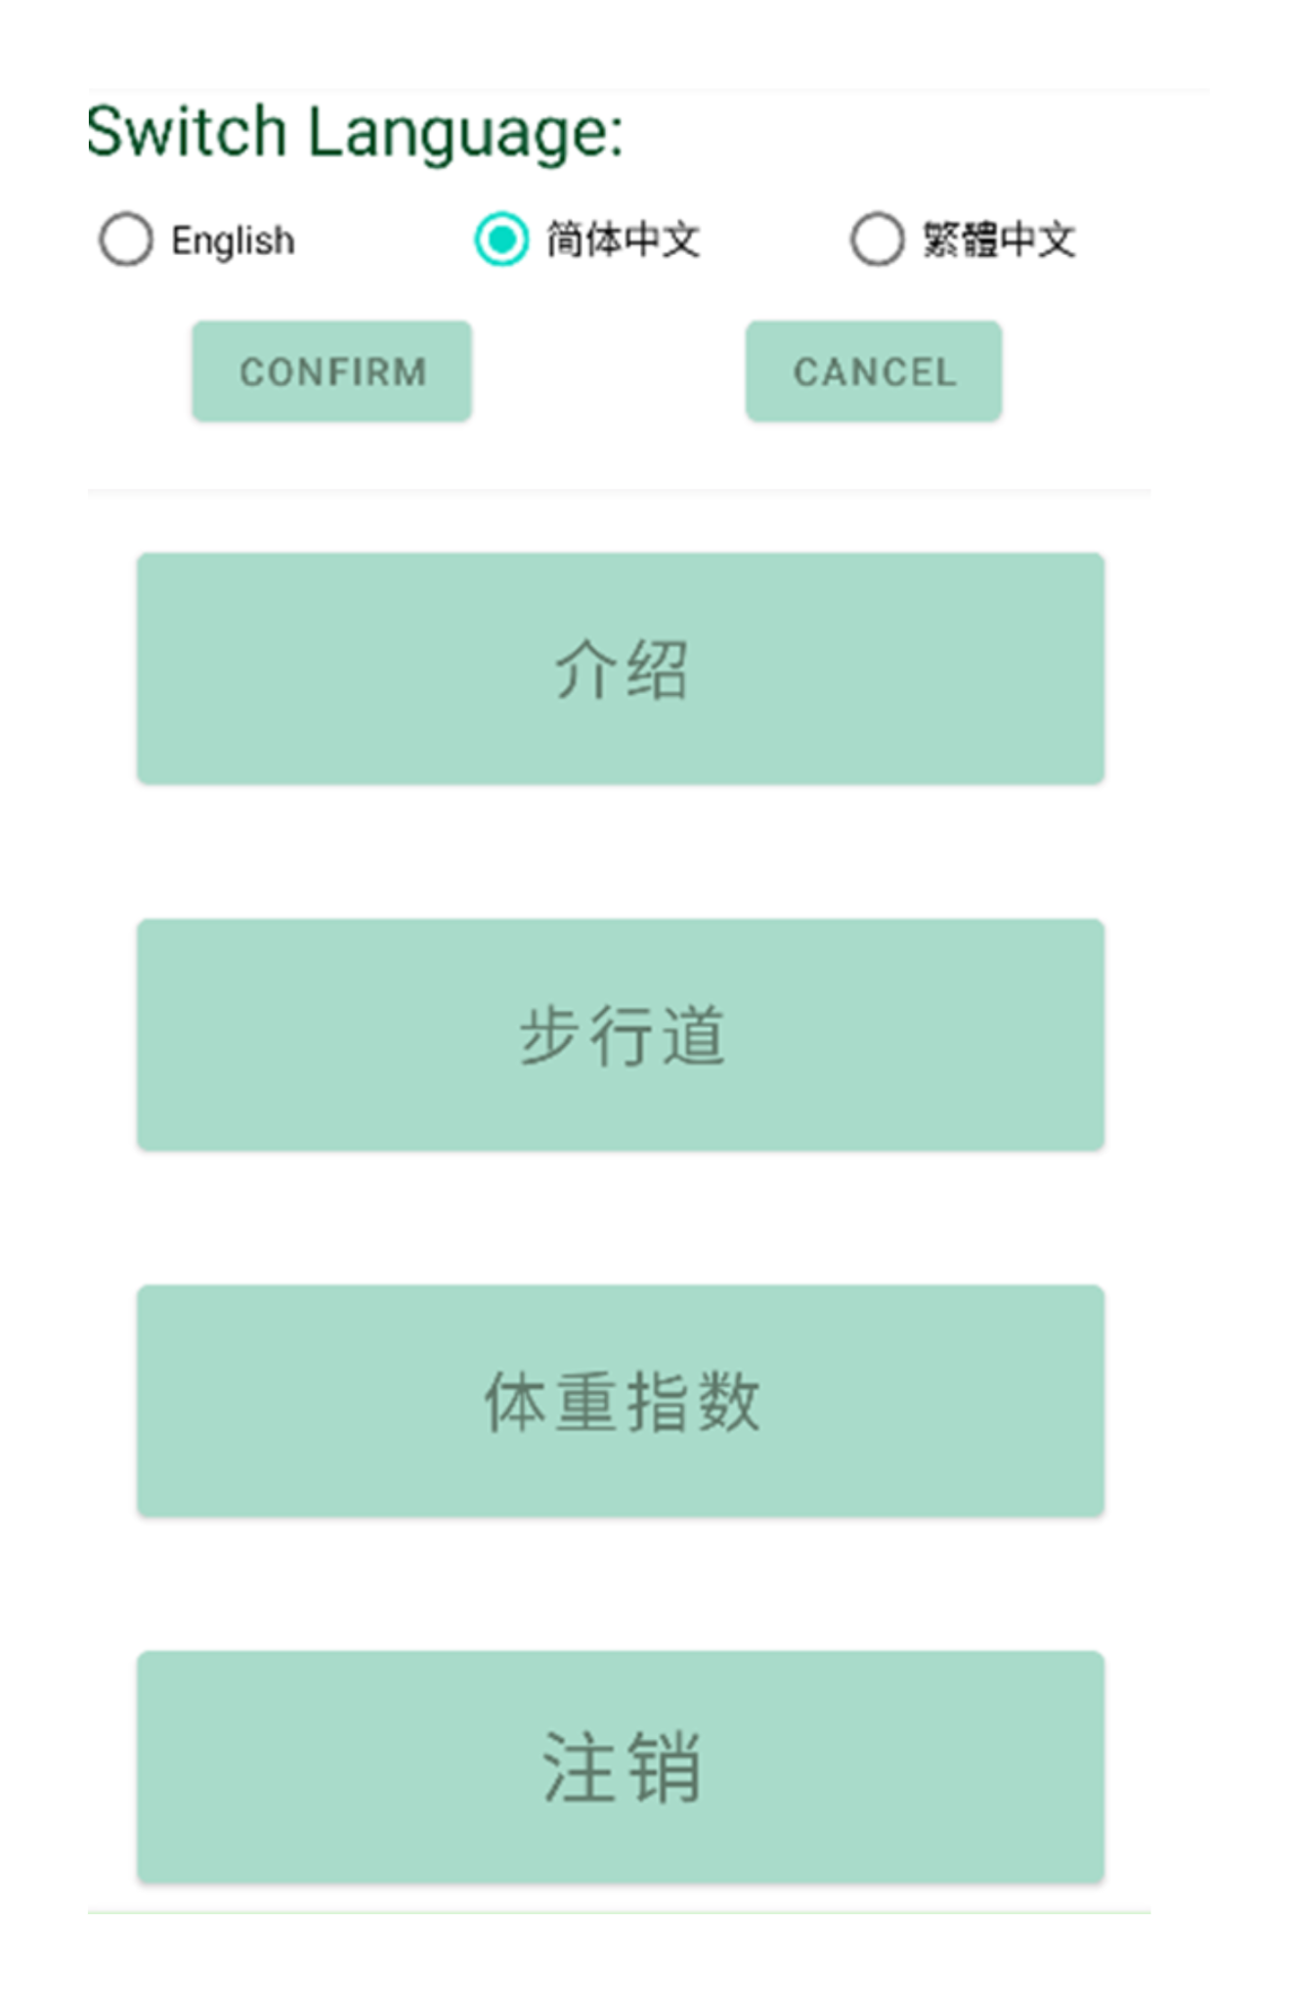

(Figure 7.2a) (Figure 7.2b)

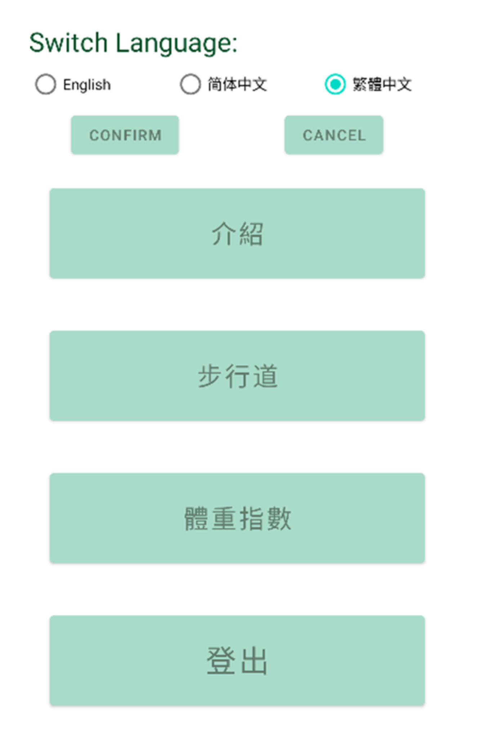

(Figure 7.2c)